1135 Waivers
When the President declares a disaster or emergency under the Stafford Act or National Emergencies Act, and the HHS Secretary declares a public health emergency under Section 319 of the Public Health Service Act, the Secretary is authorized to take certain actions in addition to her regular authorities.
Examples of these 1135 waivers or modifications include:
- Conditions of participation or other certification requirements
- Program participation and similar requirements
- Preapproval requirements
- Requirements that physicians and other health care professionals be licensed in the State in which they are providing services, so long as they have equivalent licensing in another State (this waiver is for purposes of Medicare, Medicaid, and CHIP reimbursement only – state law governs whether a non-Federal provider is authorized to provide services in the state without state licensure)
- Emergency Medical Treatment and Labor Act (EMTALA)
- Stark self-referral sanctions
- Performance deadlines and timetables may be adjusted (but not waived)
- Limitations on payment for health care items and services furnished to Medicare Advantage enrollees by non-network providers

These waivers under section 1135 of the Social Security Act typically end no later than the termination of the emergency period, or 60 days from the date the waiver or modification is first published unless the Secretary of HHS extends the waiver by notice for additional periods of up to 60 days, up to the end of the emergency period.

1135 Waiver Request Communication Method- Best Practice
The specific State Department of Health should provide responses to the following basic questions for any impacted provider seeking a potential 1135 waiver:
- Provider Name/Type
- Full Address (including county/city/town/state)
- CCN (Medicare provider number)
- Contact person and his or her contact information for follow-up questions should the Region need additional clarification
- Brief summary of why the waiver is needed. For example: CAH is the sole community provider without reasonable transfer options at this point during the specified emergent event (e.g., flooding, tornado, fires, or flu outbreak). CAH needs a waiver to exceed its bed limit by X number of beds for Y days/weeks (be specific).
- Consideration – Type of relief you are seeking or regulatory requirements or regulatory reference that the requestor is seeking to be waived.
- There is no specific form or format that is required to submit the information, but it is helpful to clearly state the scope of the issue and the impact. If a waiver is requested, the information should come directly from the impacted provider to the appropriate Regional Office mailbox with a copy to the appropriate State Agency for Health Care Administration to make sure the waiver request does not conflict with any State requirements and all concerns are addressed timely.

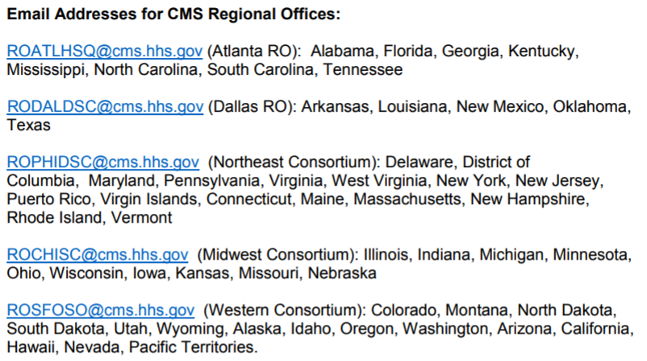

There is no requirement under section 319 of the PHS Act, nor under section 1135 of the SSA that a state or other entity make a formal request for a PHE declaration or an 1135 waiver.
When state or local officials believe that a PHE declaration and 1135 waivers are needed to assist the response to a particular event, HHS encourages them to work with the HHS Regional Emergency Coordinator at the HHS regional office in their area who can help facilitate the request.
Hospitals, healthcare entities, and healthcare providers who have concerns about Medicare, Medicaid, and SCHIP requirements should contact the CMS regional office in their area which can help address such concerns.

Role of the Facility under an 1135 Waiver
The "role of the facility under a waiver declared by the Secretary, in accordance with section 1135 of the Act, may be the provision of care and treatment at an alternate care site identified by emergency management officials."
Typically, if a decision is made to evacuate the facility, residents will be evacuated to other healthcare facilities which the facility has an agreement with. In cases where an 1135 waiver may not be, the facility will follow procedures as outlined in the Full Building Evacuation Plan.
In the event emergency management officials determine that residents must be evacuated to an Alternate Care Site versus another healthcare facility, the following actions will be taken into consideration by the Incident Command team:
- Activation of:
  - The Incident Command System to manage the facilities’ response
  - The Full Building Evacuation Plan to package/prepare and track residents
  - Mutual aid plans, written agreements, or memorandum of understanding with other healthcare facilities, suppliers, and vendors
- Notification – Through assigned roles and responsibilities in the Incident Command System, external notifications will be made with the following:
  - Local emergency responders and emergency management officials
  - Local and state health departments
- Communications – The following groups will be communicated with through assigned roles and responsibilities in the Incident Command System:
  - Residents and their Responsible Parties
  - Staff – On-duty and off-duty
  - Local/state officials, as necessary
    - The facility will contact the state health department to coordinate efforts during a declared emergency in which there is a waiver of federal requirements under section 1135 of the Act.
  - News Media
  - Local community via the News Media
- Resources and Assets - The Incident Commander will direct an assessment be completed to determine what resources and assets will be needed at the Alternate Care Site in order to provide for the safety, security, and care of residents to include, but not be limited to, the following:
  - Beds, Cots, Mattresses
  - Commodes and Personal Disposables (briefs, etc.)
  - Privacy Screens/Dividers
  - Linen Supplies (Sheets, Blankets, towels, washcloths, etc.) and Pillows
  - Emergency Cart/Box, AED, Vital Sign Equipment
  - Portable Suction, Portable Oxygen w/ regulators, Oxygen concentrators
  - Medical Supplies and Medical Equipment
  - Medication Carts/Drawers including medications and associated medication administration documentation
  - Lifts
  - Wheelchairs, Geri-Chairs
  - Walkers, canes, and other mobility devices
  - Tap Bells or other devices that can be used to notify staff
  - Resident charts and forms to document continued resident care
  - Adequate supply of food, water, dietary supplements, etc.
  - Personal Protective Equipment (Gloves, masks, hand sanitizer, etc.)
  - Isolation equipment and supplies
  - Extra wristbands, markers, paper supplies and pens/pencils
  - Copies of the Full Building Evacuation Plan and contact information for staff, emergency agencies, vendors, and suppliers

The facility may evacuate necessary equipment and supplies to the alternate care site, or may rely upon its suppliers and or vendors, or other healthcare facilities.

Staff should utilize the appropriate personal protective equipment (PPE) and always exercise Universal Precautions.

- Staffing – The facility will manage staffing as outlined in Section B: Management of Staff During a Disaster.
  - In the event a waiver is granted to waive licensure to enable individuals to assist the facility where they do not normally practice, the facility will follow the Emergency Credentialing process detailed in the EPP.

- Transportation – The facility will coordinate obtaining transportation resources with the Emergency Services/EMS via their Field Incident Command Post if they are on-site. Facility-owned vehicles and/or other healthcare facility vehicles may be utilized to transport residents, equipment, and supplies.

Serving as an Alternate Care Site
Alternatively, the facility may serve as an Alternate Care Site or Receiving Facility for another healthcare facility that is evacuating. The facility will activate its Surge Plan (Section A) which details the following:
- Notification and communications
- Assessment of impact on facility operations
- Assessment of surge beds and locations within the building
- Assessment of necessary surge equipment & supplies
- Staffing
- Establishment of a triage area; triage and tracking of incoming residents
- Credentialing of Staff from the evacuating facility or volunteers

